Central Lancashire Construction Skills Hub
Impact & Engagement Summary Report
2016-2019

Scope & Context
The Central Lancashire Construction Skills Hub aims to provide support to the construction industry in Preston and South Ribble, to ensure the social and economic benefit for the people of Central Lancashire.

Research carried out for the Lancashire Enterprise Partnership on Skills and Employment in 2015 and commissioned to provide a basis for future action in supporting skills development in Lancashire, clearly identifies both the opportunity and risk associated with the demand for and supply of construction skills at all levels. This work was further enhanced by more recent research by the Construction Industry Training Board focusing on the gap in skills based on current skills levels and Lancashire’s project pipeline.

As an initial response to the City Deal agenda, partners including Preston’s College, Local Authorities, CITB, Calico and the construction sector themselves came together to seek a collaborative response.

Initially that response has focused primarily on maximising the impact and effectiveness of existing provision, sharing information, creating a virtual entity in the Central Lancashire Construction Skills Hub.

This has ensured a strong level of co-ordination and shared response to both the challenge and the opportunity.

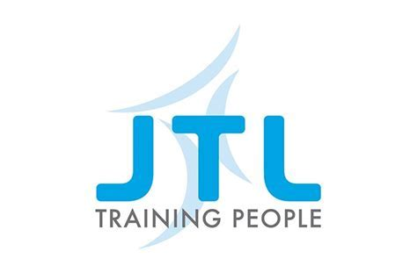

Strategic Objectives
The primary objectives are to deliver a coordinated and collaborative approach to training in Central Lancashire by delivering against the objectives detailed below:

- Coordinate and deliver Central Lancashire Construction key sector updates – Providing information on the economic and construction activity across the region, engaging large construction organisations and SMEs and the self-employed.

- Create Employment & Skills Opportunities for the community of Central Lancashire

- Deliver a centralised coordinated approach to the procurement of training services within the construction industry

- Widening participation & the promotion of the Construction & Education sector in Primary, Secondary, and Further Education & Higher Education.

Events & Engagement
Coordinate and deliver Central Lancashire Construction key sector updates – Provide detailed information on the economic and construction activity across the region, engaging large construction organisations, SMEs and the self-employed.

Number of Events delivered | SMEs engaged & Attended | Large employers / Tier 1 contractors attended | Local Authorities and Other public organisations
12 | 307 | 14 | 7

The events delivered have provided important regional updates from three key local authorities, which detailed strategic information of developments which provide procurement, contracting and employment opportunities for employers and the community of Central Lancashire.

The events consisted of:
- City Deal & Local Authority update on regional residential and industry projects
- Employment & Skills Support workshops for SMEs
- Pathway to Construction Events (College learners to Apprentices)
- Meet the Buyer Events (Procurement support for SMEs)

Bowmer & Kirkland Meet the Buyer Event 2019

Employment & Skills
Create Employment & Skills Opportunities for the community of Central Lancashire
The Central Lancashire Construction Skills Hub has enabled learners and employers to access a diverse curriculum and has significantly contributed to an increase in Apprenticeships in Construction (Central Lancashire) and improvements in the progression of learners to sustainable employment.

ESFA 16-18 Classroom based Study programmes | 2016-2017 | 2018-2019 | 2019-2020
 | 176 | 229 | 262

ESFA 16-18 Classroom based Study programmes  Progressions from Classroom based learning to Apprenticeships | 2016-2017 | 2018-2019 | 2019-2020
 | 63 | 77 | 82 (Projected numbers)

14-16  Secondary School Construction Programme GSCE - Prog 8  (EWLF) | 2016-2017 | 2018-2019 | 2019-2020
 | 11 | 57 | 102

Adults Learners Progressing to Sustainable Employment & Further Education | 2016-2017 | 2018-2019 | 2019-2020
 | 78% | 87% | 90% (Target KPI)

Apprenticeship starts  Excluding Building services | 2016-2017 | 2018-2019 | 2019-2020
 | 133 | 157 | 190 (Projected numbers)

Procurement and Training Support
Deliver a centralised and coordinated approach to the procurement of training services within the construction industry
The Central Lancashire Construction Skills Hub has coordinated the communication and planning of employment and skills opportunities within the area, communicating and advising contractors on Employment and Skills plans, to enable work placements, apprenticeships and engagement visits for learners in Central Lancashire.
The Construction Hub has advised and referred learners to partner providers to ensure the correct provision and services are procured and delivered.

Example of Actively Engaged Developments:
Bowmer & Kirkland: UCLan Adelphi Square
Seddon’s Goosnargh: Residential Housing development
Taylor Wimpy: Pickering’s Farm

Curriculum Development aligned to City Deal Activity
Civil Engineering Case Study
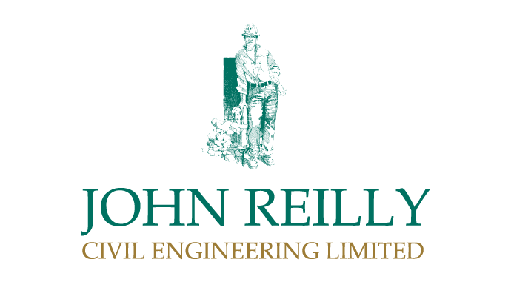

The Central Lancashire Construction Skills Hub has enabled the creation of a bespoke Civil Engineering apprenticeship programme, to address the skills needs of John Reilly Civil Engineering in Lancashire.

The programme has two active cohorts of apprentices and will see a third recruited in October 2019.
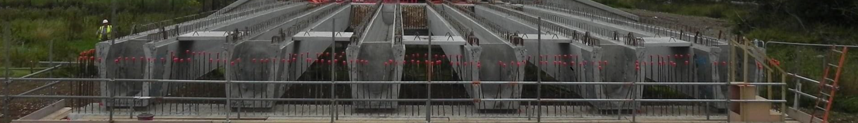
The apprenticeship programme will enable the creation of over 40 apprenticeships in the space of two years.
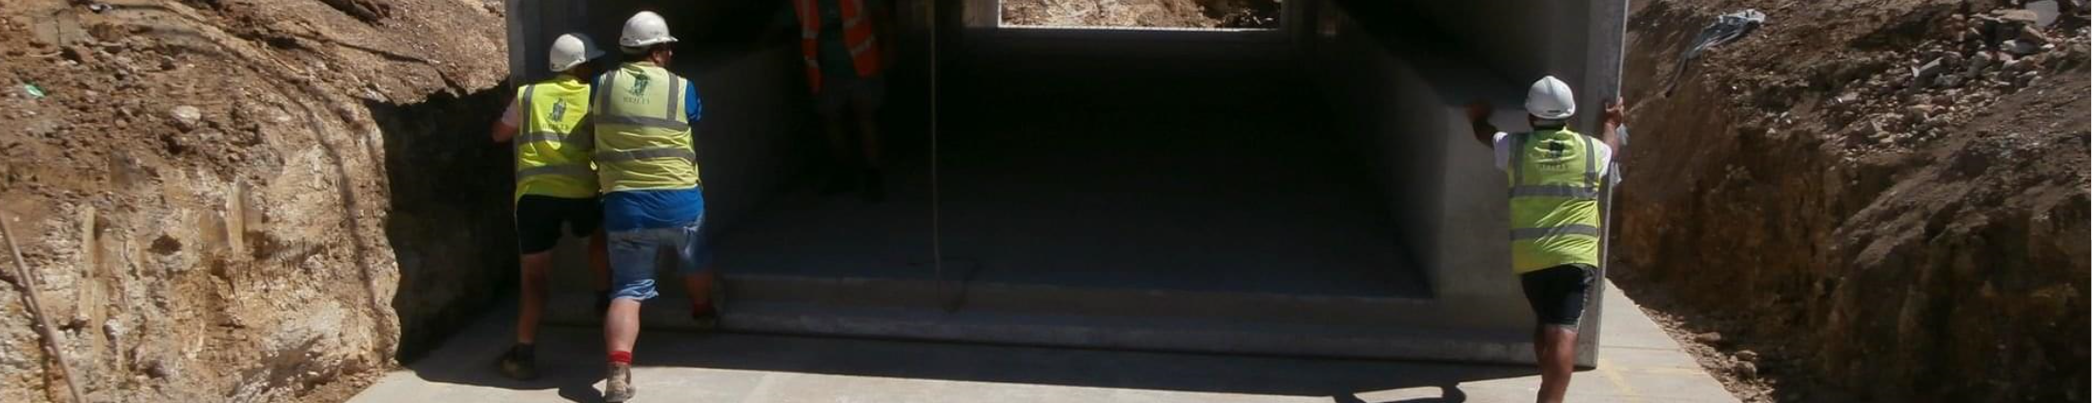

The programme has seen collaboration between the Hub, Preston’s College & Monk’s training services in Leyland, to enable the design and delivery of specialist Civil Engineering training to ensure learners are ready to progress and impact on the Civil Engineering industry.

Widening Participation
The promotion of the Construction & Education sector in Primary, Secondary, Further Education & Higher Education.
Bridge the Gap (Construction & Civil Engineering Masterclass)
The Central Lancashire Construction Skills Hub has delivered masterclass impact sessions to Secondary Education establishments in the 2018-2019 academic year.
This high impact session consists of Preston’s College delivery staff and employers or apprentices employed within the industry providing information on possible career pathways in technical & Professional areas in Civil Engineering & Construction. The session is also aimed at promoting project management skills in the industry together with teamwork, English, Maths resilience and communication.
Bridge the Gap Masterclass | Schools Engaged | Learners participated | Staff trained to deliver
 | 23 | 3220 | 12

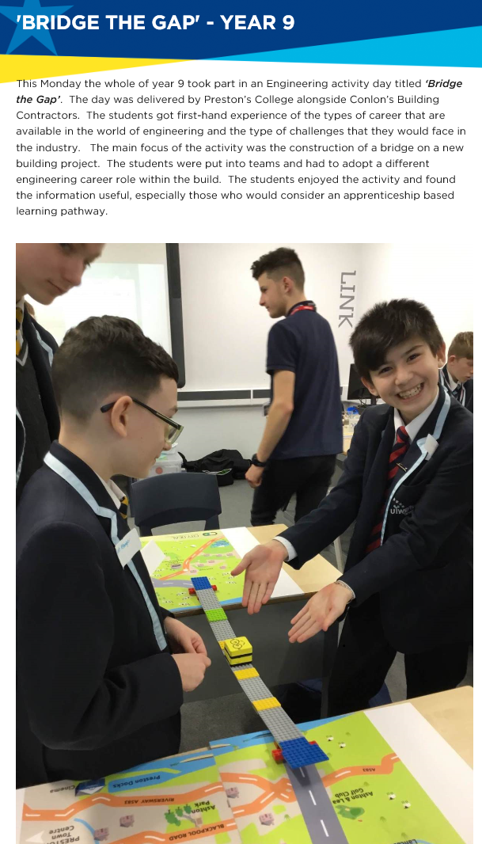

Fulwood Academy, Bridge the Gap Masterclass 2019

Construct@Preston Skills Competition
Over the last three academic years since 2016 The Hub has delivered a skills competition for 13-16 year-old Secondary school learners in Central Lancashire. This has involved learners participating in skills challenge in professional and trade occupational areas, providing insight and awareness of career pathways and possible progression routes for secondary school learners.
Construct @Preston Skills  Competition | Schools Engaged | Learners participated | Events Since 2016
 | 22 | 326 | 3
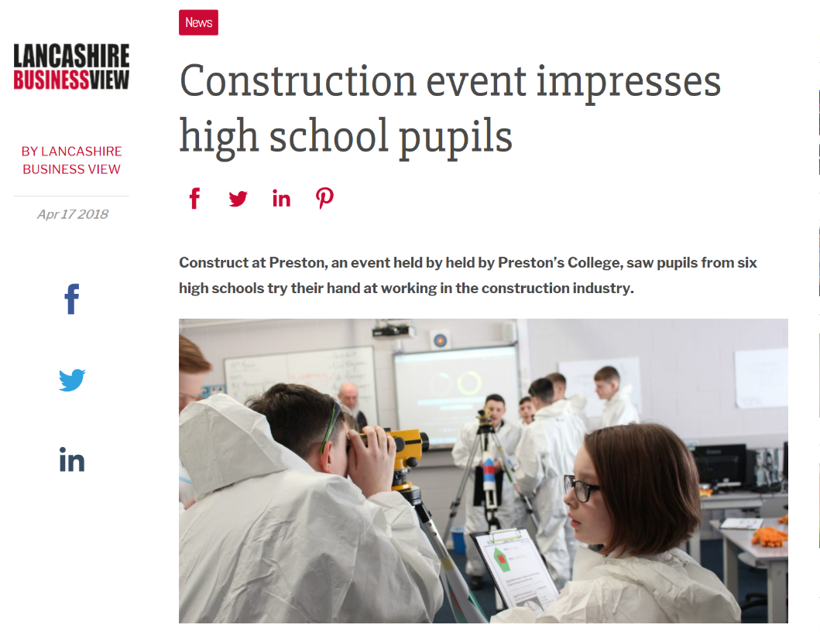

Construct@Preston Professional Construction
Maths & Surveying skills Challenge 2018

Impact Summary
The Central Lancashire Construction Skills Hub was created as virtual entity with funding from the LEP (Lancashire Enterprise Partnership) of £30,000 for three years of sustained delivery and development of activity in Central Lancashire.
Objective
1. Coordinate and deliver Central Lancashire Construction key sector updates – detail information on the economic and construction activity across the region, engaging large construction organisations and SMEs and the self-employed.

Success Measure
Engage more SME & Large organisations in Construction training and procurement opportunities

Impact
Over 12 events delivered, 307 SMEs engaged in procurement and education & training events.

Objective
2. Create Employment & Skills Opportunities for the community of Central Lancashire

Success Measure
Increase the participation of Construction Curriculum and regulated study for 14-16-year-old learners, 16-18s, and also in Higher Education/Higher level Apprenticeships.

Impact
Three years of increasing school leaver enrolments in Construction & The Built Environment,
Three years of growth in apprenticeship starts in Construction & Building Services
Three Years of increasing numbers of Higher Education apprenticeships at Level 4
Three years of increasing numbers of 14-16 learners participating in Construction education regulated study,

Objective
3.Deliver a centralised and coordinated approach to the procurement of training services within the construction industry

Success Measure
Create collaboration between local authority, Principal Contractors & Education providers to enable more opportunities or the community of Lancashire.

Impact
An increase over three years of learners participating in External work experience 47% in 2016-2017 at Level 2 & 3 to 74% in 2018-2019
An increase in industry engagement within education and delivery,
SME increase in the engagement of the procurement of apprenticeships.
6 Principal contractors now engaged and recruiting apprenticeships in Central Lancashire

Objective
4. Widening participation & the promotion of the Construction & Education sector in Primary, Secondary, and Further Education & Higher Education.

Success Measure
Increase the number of Individuals receiving Careers Information, Advice and Guidance on the career pathways in Construction & Civil Engineering professional and occupational roles.
Increase enrolment at Level 1 – Level 4, of Construction & The Built environment.

Impact
Over 3000, Learners participated in the Bridge the gap masterclasses
Three successive years of growth in school leaver enrolments
An increase in 14-16-year-old learners participating in Construction education 14 (2016) to 104 in 2019, currently studying towards a regulated construction programme whilst enrolled at secondary school.

